**🏡 Exterior Painting in Isaacs, Canberra – Pergola, Walls & Gutters**

**Location:** Isaacs, Canberra  
**Published:** June 1, 2025  
**Filed under:** Exterior Painting Canberra | House Painters Canberra

At Experience Painting Canberra, we recently completed a stunning exterior painting project in Isaacs, transforming the façade of a residential home with precision and care. This job involved the full repainting of garage doors, exterior walls, gutters, and a timber pergola, offering a complete refresh to the property’s exterior.

Our team of experienced house painters in Canberra delivered expert services using premium Dulux paint, ensuring both weather resistance and a flawless finish. As with all our exterior house painting Canberra services, we followed a structured process—beginning with thorough surface preparation, masking, and sanding—before applying durable coats designed for long-lasting protection.

🎨 **Our Exterior Painting Canberra Services Include**

* Exterior wall painting using weather-shield paint
* Garage door painting with a durable enamel finish
* Pergola and timber surface restoration and staining
* Gutter and fascia painting in matching tones
* Clean, efficient, and non-intrusive project execution

📍 Serving:  
We proudly serve clients throughout Canberra, including Isaacs, Woden, Gungahlin, Tuggeranong, Belconnen, and nearby suburbs. Whether you're searching for residential house painters Canberra, commercial painters, or painting contractors Canberra, we’re your trusted local team.

🧱 Why Clients Choose Experience Painting Canberra:

* Skilled team of professional painters in Canberra
* Top-rated painting company Canberra for exterior & roof work
* Fully insured, OH&S compliant, and warranty-backed results
* Trusted by homeowners, real estate agents, and builders

This Isaacs exterior project demonstrates how a fresh coat of paint can dramatically improve curb appeal. Contact us today for reliable and professional house painting services Canberra can count on.

📸 Scroll down to view before-and-after photos of this transformation!

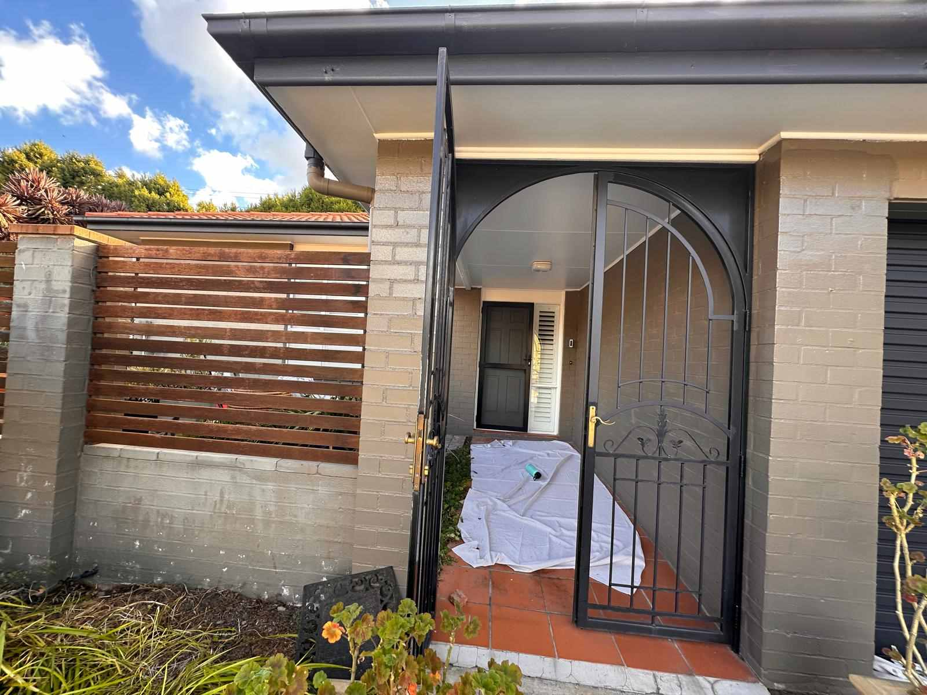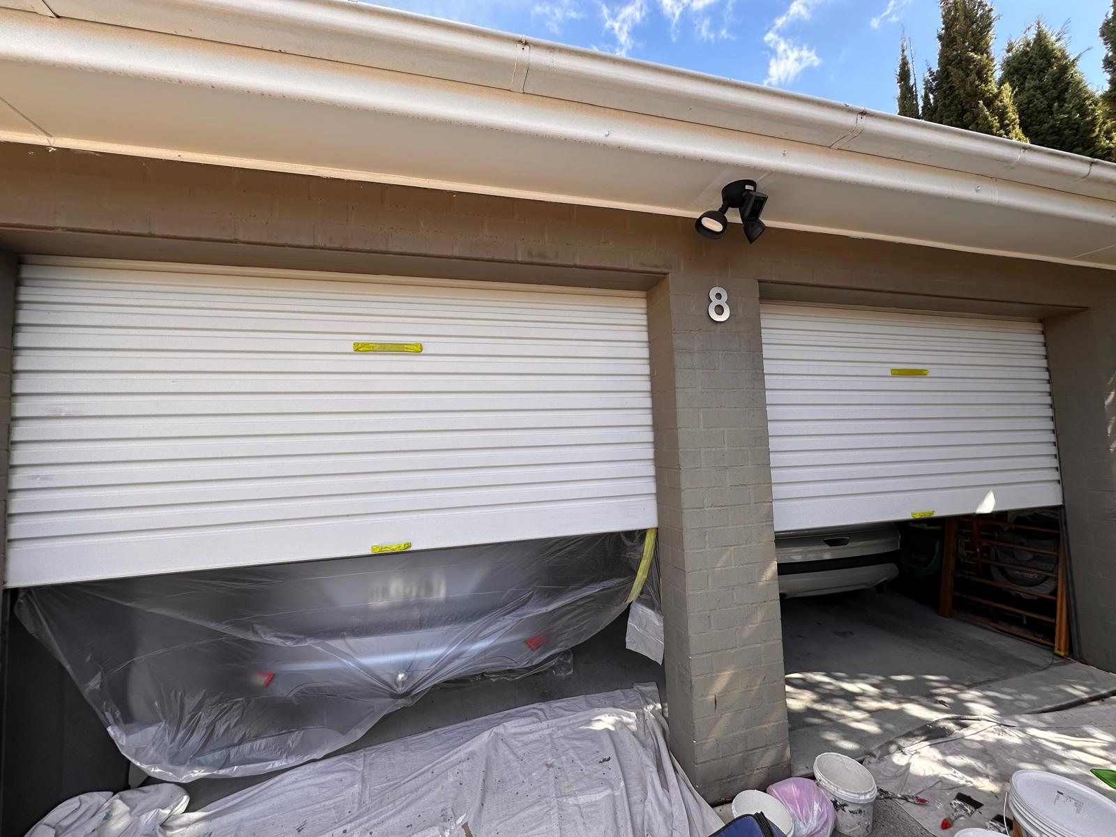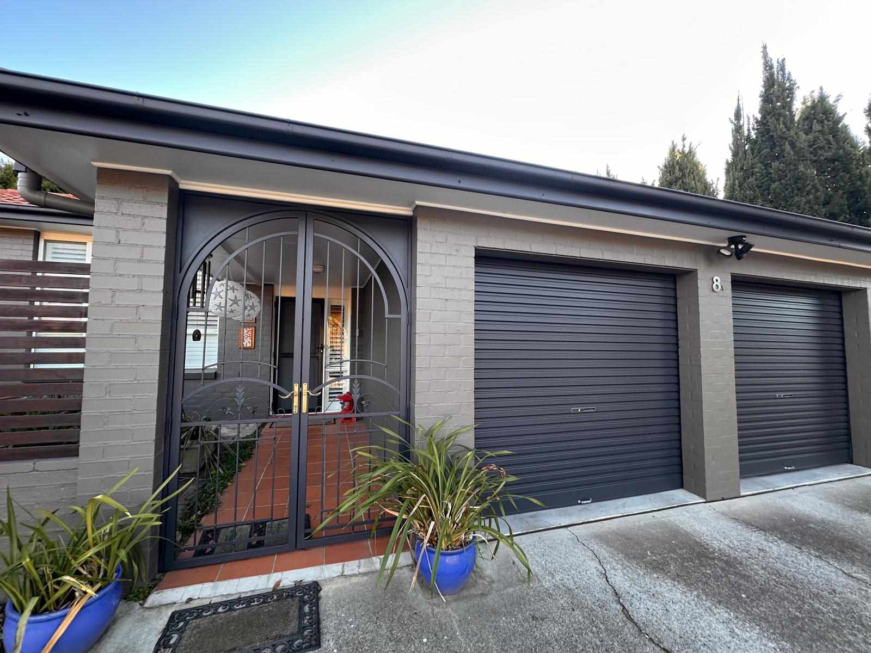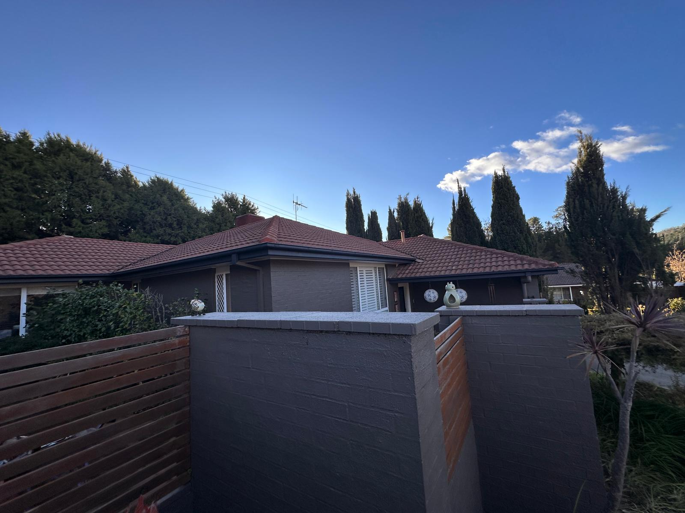

📍Proudly delivering professional exterior painting, pergola restoration, and garage door painting services to homes across Canberra—including Isaacs, Woden, Garran, Farrer, and nearby suburbs.

Simply fill out the form below, and one of our experienced exterior painting specialists will get in touch with a free quote and expert advice to give your home's exterior a refreshed, long-lasting finish.

To learn more about our exterior painting services in Canberra—including pergola painting, wall repainting, garage door refinishing, and gutter restoration—please contact the friendly team at Experience Painting on 0478 149 988.