**SEO Page Title:**

SEO Milestones: What Canberra Businesses Can Expect | DigiSiam

**Meta Description:**

Discover the month-by-month SEO milestones Canberra businesses can expect. Learn how DigiSiam helps you grow your digital presence.

**Page Slug:**

seo-milestones-canberra-businesses  
**SEO Milestones: What Canberra Businesses Can Expect Month-by-Month**

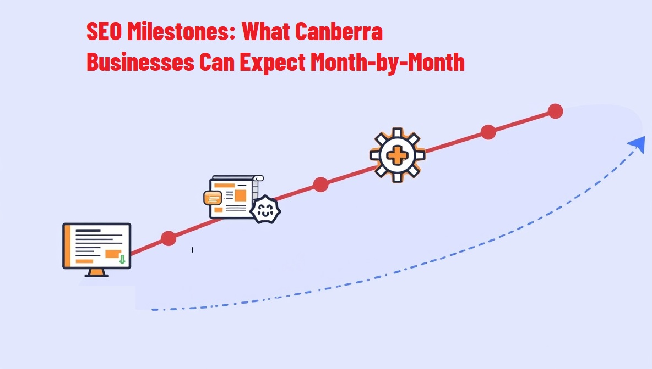

Search engine optimisation (SEO) is a long-term investment, especially for Canberra businesses aiming to stand out locally. Whether you're working with a [professional SEO agency in Canberra](https://www.digisiam.com/page/29/professional-seo-services-in-canberra) or managing your strategy in-house, it helps to understand what to expect each month.

In this guide, DigiSiam shares a clear, month-by-month breakdown of SEO milestones for local businesses—from web design readiness to traffic growth. Let’s walk through the journey to higher rankings and better online visibility.

## **Month-by-Month SEO Roadmap for Canberra Businesses**

A month-by-month SEO roadmap helps Canberra businesses grow online step by step. It starts with things like website audits and keyword research, then moves to content and page improvements. Each month builds on the last to boost your visibility and bring in more local customers. This simple, structured approach makes it easier to see progress without getting overwhelmed.

### **Months 1–3: On-Page Optimisations & Local Citations**

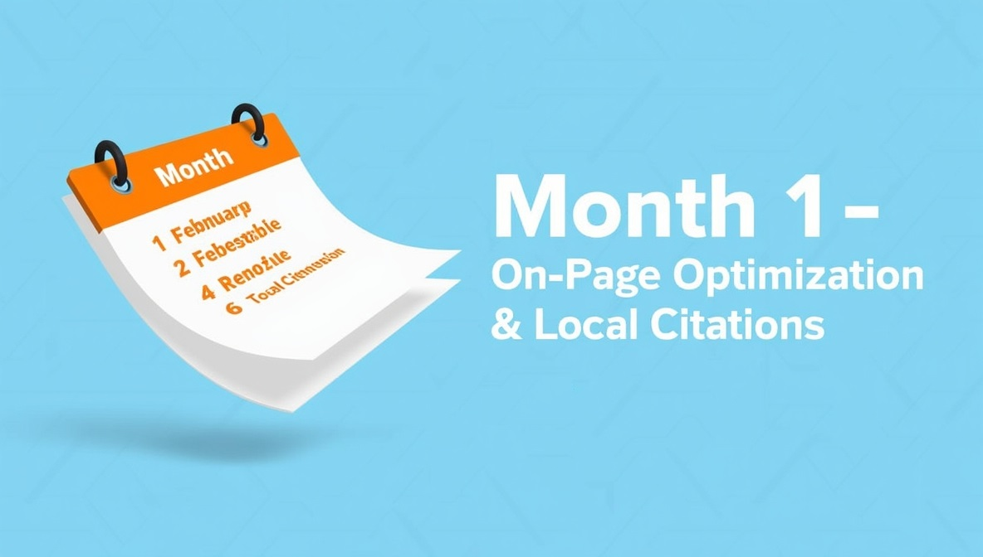

In the first three months, the focus is on building a strong and sustainable SEO foundation that supports long-term growth. This phase helps fix important website issues and ensures your website follows search engine best practices. Without this solid start, it can be difficult to achieve strong rankings or consistent traffic over time. Here’s a closer look at what happens during these critical first months:

**✅ Website Audit & Strategy**

* A full check of your website to find technical and content problems
* Looking at what your local competitors are doing (like in Gungahlin and Tuggeranong)
* Finding the best keywords people search for.

**⚙️ Technical Fixes & Setup**

* Page speed optimisation and mobile responsiveness improvements
* Fixing issues that stop search engines from reading your website properly
* Setting up tools like Google Search Console and Analytics to track your website’s performance

💡 Tip: If your website isn’t mobile-friendly, now’s the time to learn [why your Canberra business needs a mobile-friendly website today.](https://www.digisiam.com/blog/12/mobile-friendly-website-canberra-business)

**📝 On-Page Optimisation**

* Updating page titles, meta descriptions, and header tags
* Optimising service pages with keyword-rich, user-focused content
* Improving internal linking
* Enhancing user experience and website navigation

**📍 Local SEO Enhancements**

* Improving your Google Business Profile
* Making pages for each area you serve
* Adding your business to local directories to boost visibility

By the end of Month 3, your website will be faster, more relevant, and better positioned in local search, ready to attract qualified traffic and convert visitors into leads.

### **Months 4-6: Content traction, backlink growth**



With your website fully optimised and technically sound, the next step is to boost your credibility and visibility in the Canberra market. This phase focuses on building trust with both search engines and your audience. Start by earning backlinks from reputable Canberra-based directories and local publications.

* Build backlinks from Canberra-based directories and publications
* Encourage reviews on Google and other platforms
* Launching a blog targeting local search terms like “best SEO agency Canberra”
* Writing FAQs and helpful guides to answer customer questions
* Producing content for specific services in Canberra

💡 Tip: We offer a [professional blog writing service](https://www.digisiam.com/page/25/professional-blog-writing-service) to ensure your content converts.

### **Month 6+: Sustained traffic and conversions**

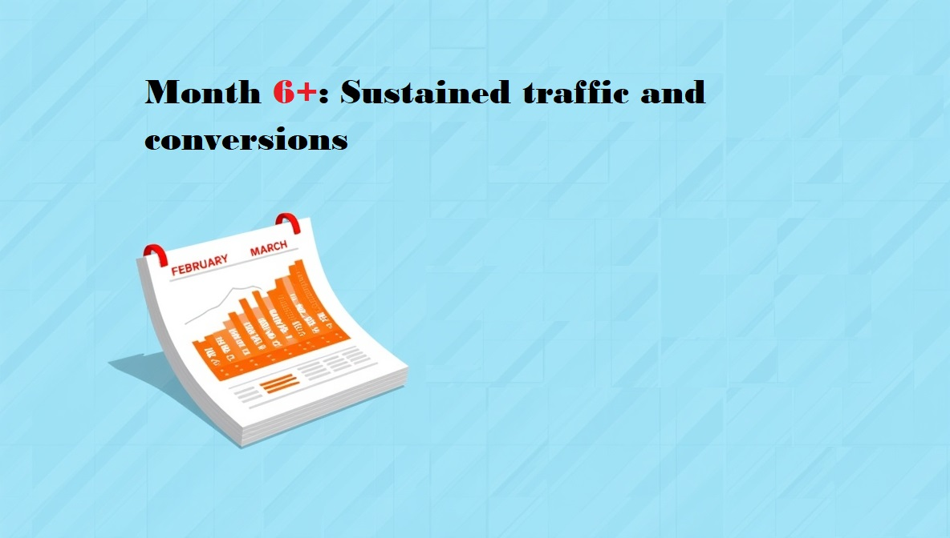

At this stage, your SEO work should be paying off with better rankings, more visitors, and stronger engagement. Use your analytics to see what’s working and adjust your strategy to keep up with trends in the Canberra market.

* Keep an eye on key stats like bounce rate, time on website, and conversions
* Test different buttons and landing pages to see what works best
* Try paid ads to reach more people (like Google Ads)
* Create more blogs and build more backlinks
* Check which keywords bring the best results
* Use your data to adjust your strategy and follow new trends

## **Comparison Table: Custom SEO Strategy vs. Generic SEO Tools**

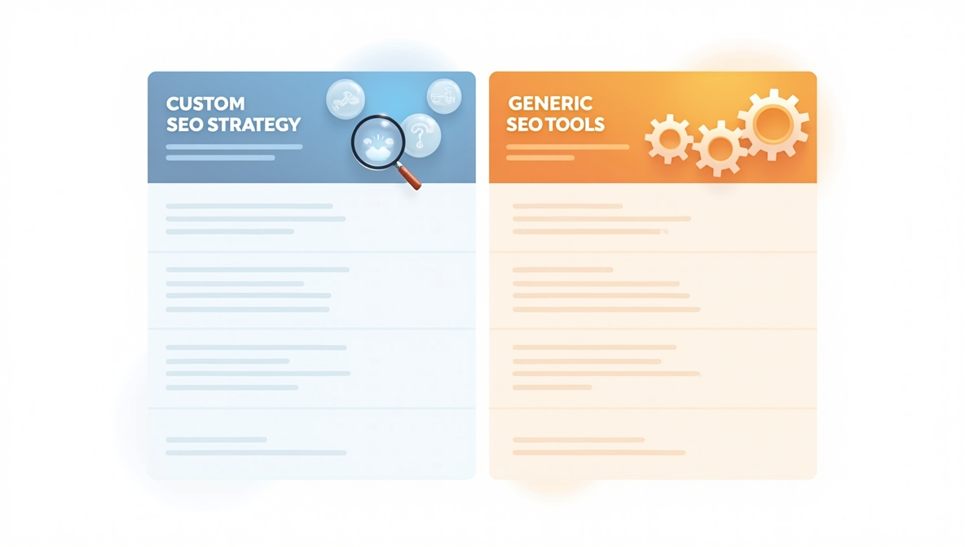

When it comes to growing your online presence, not all SEO solutions are created equal. The table below compares a custom SEO strategy—tailored to your specific business goals, location, and audience—with generic SEO tools that offer one-size-fits-all features. Use the comparison below to see which approach best fits your needs.

|  |  |  |
| --- | --- | --- |
| **Feature** | **Custom SEO with DigiSiam** | **Generic SEO Tools** |
| Keyword Research | Localised to the Canberra market | General/global focus |
| Technical Audits | In-depth and tailored | Basic scans only |
| Content Creation | Customised blog + web content | Generic AI content |
| Local SEO | Includes suburb-level targeting | Often missing |
| Reporting & Consultation | Monthly insights with strategy tweaks | Limited or no support |

**What Impacts Your SEO Timeline?**

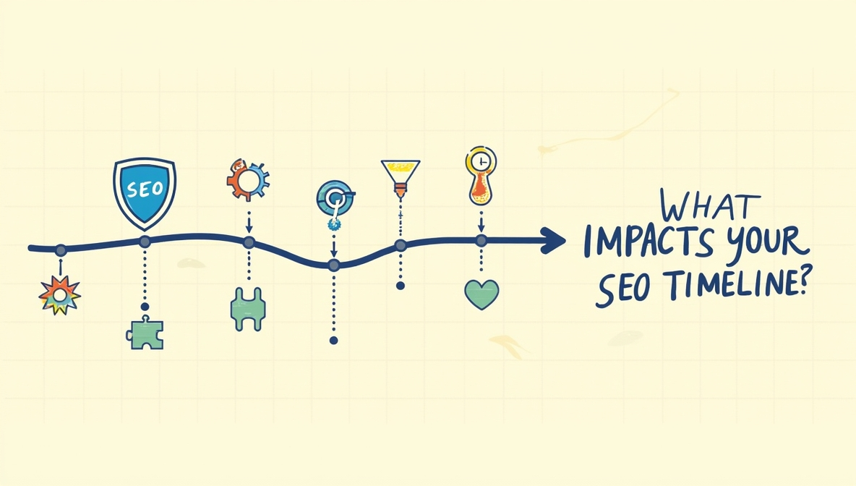

Several key factors can influence how quickly you see results from your SEO efforts. One major factor is competition level—if you're targeting high-competition keywords, it may take longer to rank compared to local phrases. Website health is also important; technical issues like slow load times, broken links, or poor mobile responsiveness can hold you back, even with good content. Ensuring your website is well-optimised gives you a much stronger starting point.

Another major factor is your content quality and strategy. A website that consistently publishes helpful and keyword-rich content, will perform better in the long run. Lastly, the expertise of your SEO agency plays a big role. An experienced team can help you avoid [common mistakes](https://www.digisiam.com/blog/21/common-seo-mistakes-canberra-businesses), build a smarter strategy, and get faster, more sustainable results.

## **Final Thoughts: Month-by-Month SEO That Drives Real Growth**

SEO isn’t something that brings results overnight. It’s a step-by-step process that takes planning, steady effort, and the right knowledge. By knowing what to expect each month, you can track real progress and stay focused on long-term success.

👉 Ready to take your Canberra business to the top of Google? [Contact DigiSiam today](https://www.digisiam.com/contact/11/contact-with-digisiam) for a free SEO consultation.

## **SEO Timeline FAQs for Canberra Businesses**

**How long does it take to see SEO results in Canberra?**

Most Canberra businesses begin to see SEO results within 3-6 months, depending on competition and current website performance.

**Why is local SEO important for Canberra-based businesses?**

Local SEO ensures your business ranks in Canberra-specific searches, helping you reach nearby customers and build local trust.

**What's the difference between SEO and SEM?**

SEO focuses on organic search visibility, while SEM (Search Engine Marketing) uses paid ads for immediate traffic.