**SEO Page Title:**

When to Upgrade Your Website | DigiSiam Canberra

**Meta Description:**

Learn the signs it's time to upgrade your website. Boost online performance and conversions with expert tips from Canberra's trusted web design agency.

**Page Slug:**

when-to-upgrade-website-canberra

# **When to Upgrade Your Website: A Guide for Canberra Businesses**

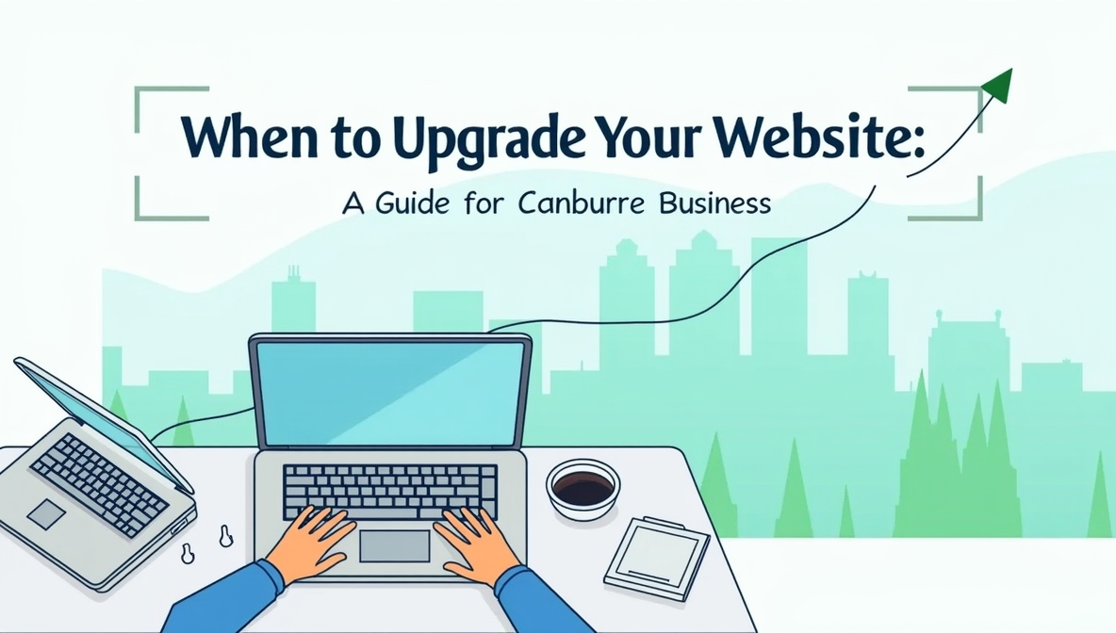

In the fast-paced digital world, having an up-to-date website is just as important as keeping any job skills or professional practices current. Just like a business professional needs to upgrade their knowledge and skills to stay relevant, a website also needs regular updates to remain effective and competitive.

But how do you know when it’s time to upgrade your website? And which parts should you focus on? Whether it’s the design, speed, security, content, or mobile responsiveness, understanding the key indicators will help you make the right decision. In this guide, we’ll explore the essential aspects of website upgrades, helping Canberra businesses understand how to keep their online presence effective.

## **Is Your Website Falling Behind? 10 Signs It's Time for an Upgrade**

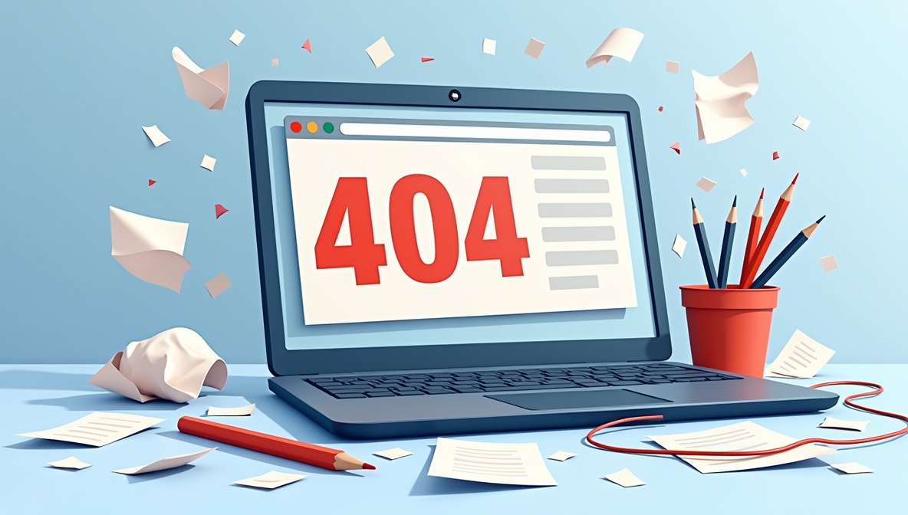

Knowing when your website is not performing well is really important. It can make a big difference in helping you reach your online goals. When a website doesn’t work as it should, it can drive away visitors and reduce your chances of success. To keep your website effective and user-friendly, it’s important to watch for some key signs that indicate it might need an upgrade or improvement.

💡Here are a few common signs that show your website might not be performing well:

### **Slow Loading Times**

People in Canberra usually leave a website if it takes more than three seconds to load. Slow pages can make visitors lose interest and move on to other websites. If your website struggles with speed, consider our [**website maintenance and support services in Canberra**](https://www.digisiam.com/page/17/website-maintenance-and-support-services-in-canberra) to optimize performance.

### **Poor Mobile Experience**

More than 60% of Canberra users access websites from mobile devices. If your website doesn’t adapt well to smartphones and tablets, you might lose a large number of visitors. A [**mobile-friendly website design**](https://www.digisiam.com/blog/12/mobile-friendly-website-canberra-business) is essential for keeping users engaged.

### **Outdated Design**

An outdated or unattractive website can make potential customers lose interest, especially in busy industries like professional services.

### **Low Search Visibility**

If your website doesn’t appear on the first pages of Google, it means your website isn’t optimized for search engines. This is a sign that you might need [**SEO services in Canberra**](https://www.digisiam.com/page/16/seo-services-in-canberra) to boost your website’s visibility.

### **High Bounce Rate**

A high bounce rate means that visitors leave your website quickly without exploring further, usually because the content isn’t engaging or the design doesn’t look appealing. Improve your user experience with our [Professional Blog Writing Service](https://www.digisiam.com/page/25/professional-blog-writing-service) in Canberra.

**Poor Visual Design**

People make quick judgments about your website based on its look. If your website has unappealing colors, messy layouts, or outdated visuals, it might give a bad first impression. Improving visual design can make visitors stay longer.

**Branding and Messaging Issues**

If your branding (like your logo, colors, and style) is not consistent on every page, it can confuse visitors. Good branding should clearly show your business identity and make your message easy to understand.

**Bad User Experience (UX/UI)**

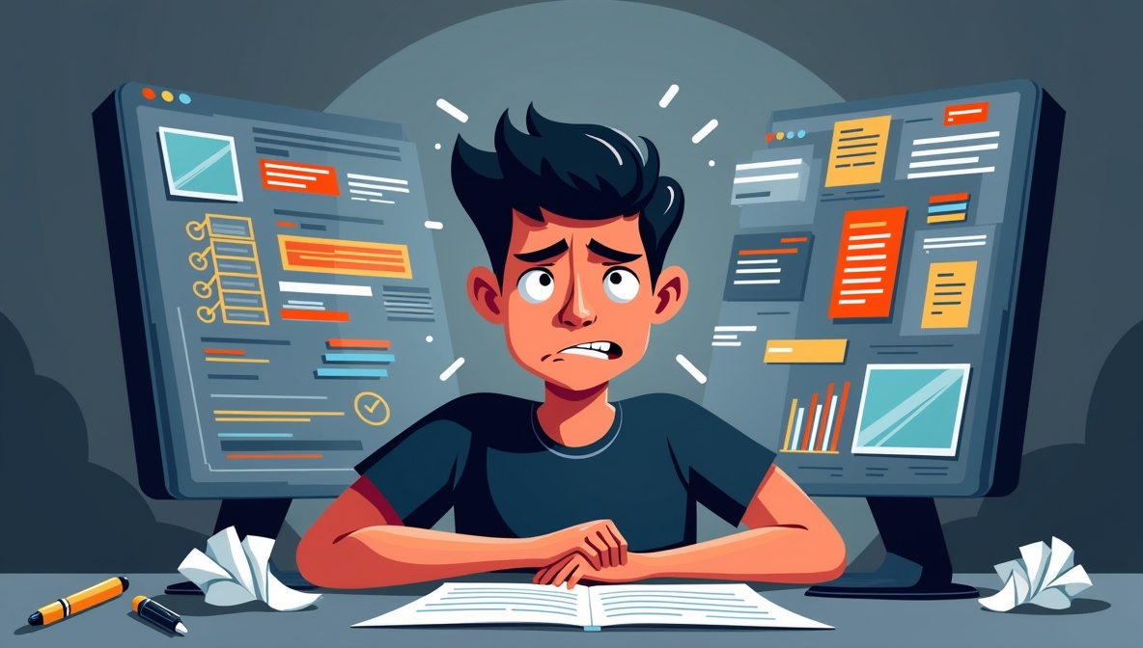

If users find it hard to navigate your website, they might leave. Good UX means visitors can easily book appointments, find information, or contact you.

**Security Problems**

An old website can have security problems, making it easier for hackers to steal data or cause other issues. Keeping your website updated helps protect it.

**Complicated Content Management System (CMS)**

If your CMS is old or hard to use, it can make updating your website difficult. A simple, modern CMS allows your team to make changes easily without needing a developer.

## **Upgraded Website vs. Outdated Website : A Side-by-Side Comparison**

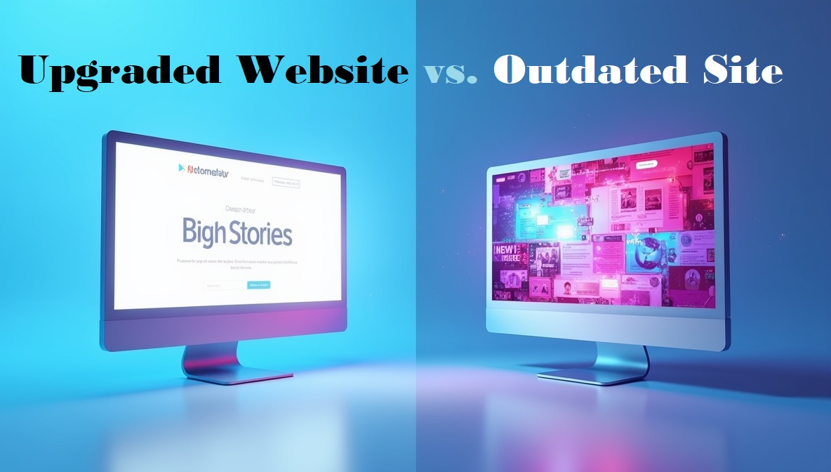

Upgraded websites work much better than outdated ones, and this can make a big difference for your business. Check out the table below to see how an upgrade can really help your website!

|  |  |  |
| --- | --- | --- |
| **Feature** | **Updated Website** | **Non-Updated Website** |
| **Security** | Safe from hackers, protected | Easy to hack, not secure |
| **Speed** | Loads fast, smooth experience | Slow to load, frustrating to use |
| **Design** | Looks modern and attractive | Looks old and boring |
| **Mobile Friendly** | Works well on phones and tablets | Hard to use on mobile devices |
| **User Experience** | Easy to navigate, user-friendly | Confusing and hard to use |
| **Search Visibility** | Shows up in search results | Hard to find on Google |
| **Branding** | Matches the company image | Outdated logo and style |
| **Content** | Fresh, up-to-date information | Old and irrelevant content |
| **Technical Issues** | Few problems, works smoothly | Many errors and broken links |
| **User Engagement** | Keeps visitors interested | Makes people leave quickly |

## **Benefits of Upgrading Your Website**

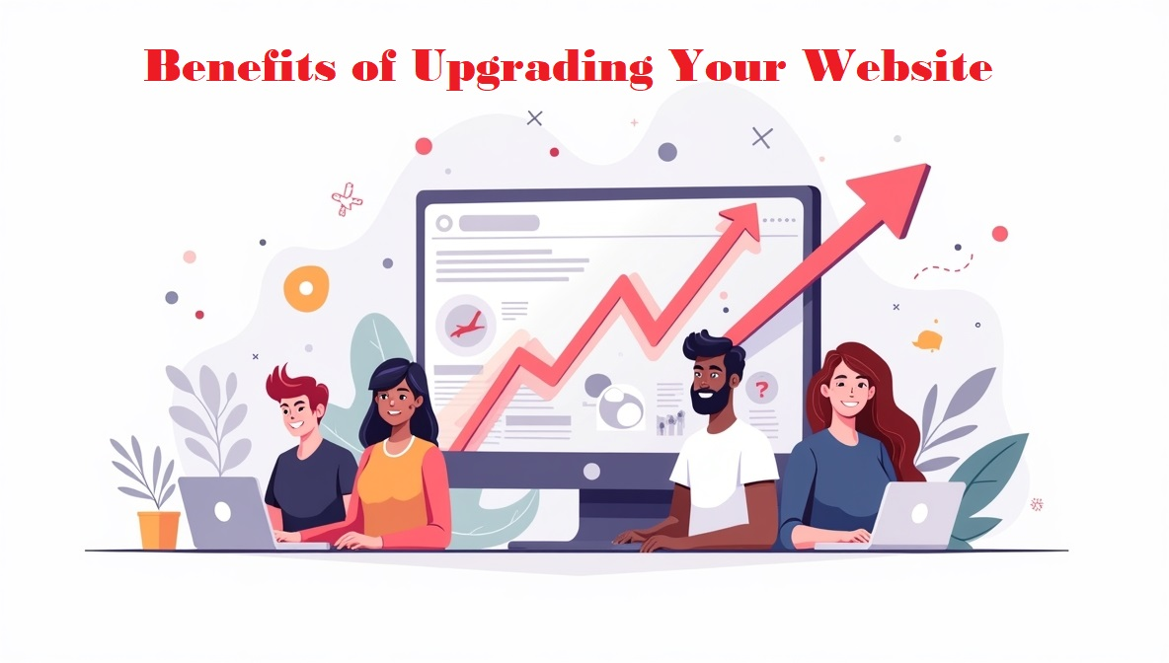

Upgrading your website offers many advantages that can help your business grow. A modern, well-optimized website is easier to find on search engines, attracts more visitors, and keeps them engaged with faster loading times, simple navigation, and mobile-friendly design. It also keeps your data safe from hackers and guides visitors to take action with clear calls to action , which can boost your sales.

For Canberra businesses, a website upgrade can make a big difference. For example, cafés in Braddon and law firms in Queanbeyan that improved their websites have seen more customer engagement and increased local traffic. A [**custom website designed by local experts**](https://www.digisiam.com/page/20/custom-web-development-in-canberra) ensures your business stands out, attracts more customers, and stays ahead of competitors.

## **Final Words: Stay Competitive with a Modern Website**

Upgrading your website isn’t just about making it look good; it’s a smart move that can really boost your business. If any of the signs we mentioned sound familiar, DigiSiam, your go-to Canberra web design agency, is here to help you improve your online presence.

👉 [Get a Free Quote Today](https://www.digisiam.com/contact/11/contact-with-digisiam) and see how we can make your website better!

## **Website Upgrade FAQs for Canberra Businesses**

**What are the key signs my website needs an upgrade?**

Some signs that your website might need an upgrade include pages taking too long to load, not working well on mobile devices, not showing up in search results, or having an old, unattractive design. If visitors leave quickly or have trouble using your website, it’s probably time for an update**.**

**How often should I upgrade my website?**

It’s a good idea to upgrade your website every 2 to 3 years. However, if you notice that your website is getting less traffic or not converting visitors into customers like it used to, you might want to update it sooner.

**Does upgrading my website improve SEO?**

Yes, upgrading your website can really help with SEO. A modern, well-designed website follows the latest SEO rules, making it easier for search engines to find you. This can help your website rank higher and get more visitors.